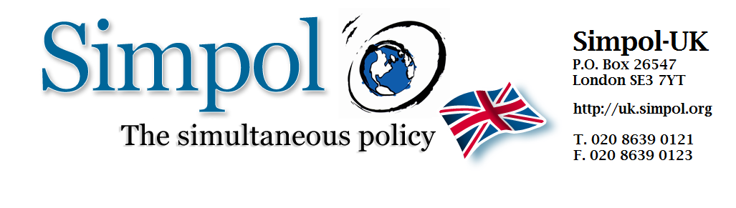
The Simultaneous Policy (Simpol) becomes fourth largest unofficial ‘party’ in UK parliament
Campaign celebrates 38% increase in elected MPs pledged to implement its global justice agenda

Following a hugely successful pre-election campaign that saw 630 candidates from across the party spectrum sign its Pledge, the citizen-led Simpol campaign is celebrating an increase in its representation in the House of Commons - with 29 elected MPs now confirmed. The number makes Simpol’s collective of MPs the fourth largest unofficial ‘party’ in Westminster.
“Simpol has always been a powerful voice for progressive global politics - and it just got louder” says John Bunzl, founder of the International Simultaneous Policy (Simpol) Campaign, to which the MPs have pledged their support. “The MPs who signed our Pledge could prove a decisive voice in favour of more integrated, global policymaking in the next 5 years. I’m looking forward to working more closely with all our MPs in the coming months to effect a better approach to solving global problems.”
The Pledge - which saw a huge increase in signatures in the final weeks before the election - is a commitment to implement a range of global policies simultaneously alongside other governments. The condition of simultaneous implementation avoids any nation suffering a first-mover competitive disadvantage – something that presently hampers substantive agreement on issues such as Corporation Tax, Tax Evasion and Climate Change.
The group includes candidates from all the major parties - including Conservative, Labour and the SNP - who echo their national success by making up 31% of Simpol’s parliamentary collective.
“The SNP have worked hard to demonstrate the importance of autonomy," says Bunzl, "yet it's clear from those who have signed the Pledge that there is also an understanding and acceptance among many of them that more binding global governance is necessary to take on the problems we cannot fight alone.”
9 of the 29 Simpol-signed MPs are women - including the Green Party MP Caroline Lucas, Plaid Cyrmu’s first ever elected female MP Liz Saville-Roberts, and Kirsten Oswald - the SNP candidate who beat Scottish Labour leader Jim Murphy to the seat he had held since 1997.
Also among the mix of pro-cooperation MPs is Labour’s Paul Flynn, whose recent interview with the BBC drew attention to the “deeply-rooted contempt for the political system” among the public, and the need for reform.
In the coming weeks Simpol will be working with all its MPs to broaden awareness and support for the campaign in parliament. The campaign continues to invite UK citizens to sign the Simpol Petition in order to encourage still more MPs to support the campaign. Simpol campaigns are also developing in other countries.
For more information contact Alex Lyons: alexander.lyons@simpol.org

